Project:

Design a traffic light system with vehicle left turn and pedestrian corssing.

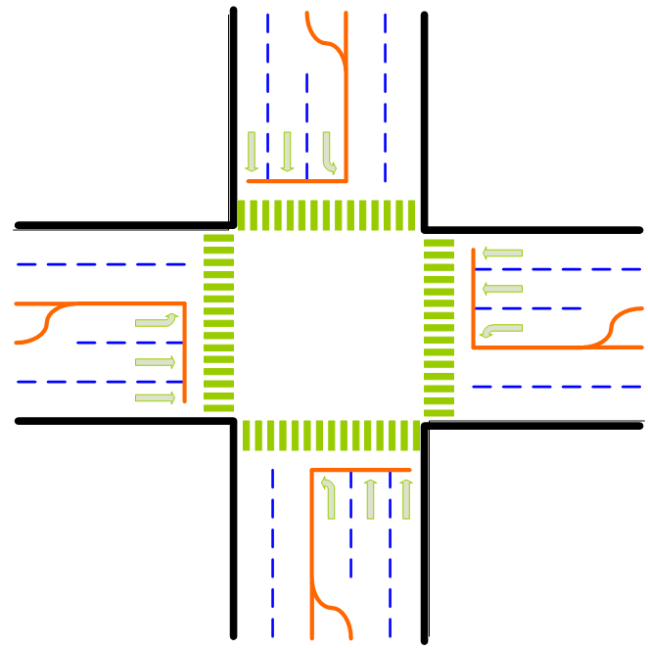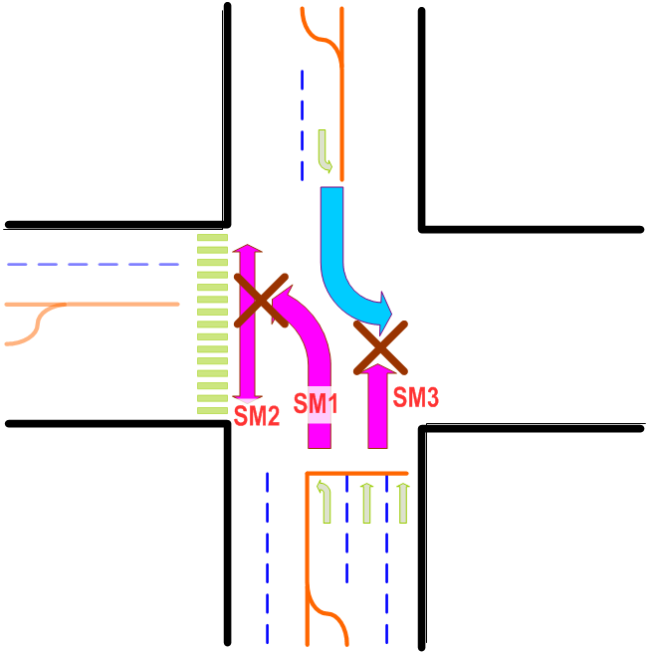

Fig 1 Fig 2

In a intersection of road like Fig 1, we name it x direction and y direction. Normally, x means the ew-direction and y means the ns direction.

Thinking process:

For each direction, we have 2 type of traffic to consider, for example, from N to S and from S to N. To make it simple we will call it “from south” or “from north” traffic. Thus, we will have 4 identical traffic mechanisms (state machines), from south, from north, from east and from west.

Traffic of from south and from north works together to form a North-South (NS) traffic.
Similarly, traffic of from east and from west works together to form a East-West (EW) traffic.

Now, each of the 4 identical traffic mechanisms includes the following operation state machine, as shown in Fig2:

- SM1: Left turn vehicles
- SM2: Pedestrian in the left hand side (usually after left turn)
- SM3: Straight traffic

At the state machine design, only two kinds of communication signals are considered, 1-cycle pulse and level to indicate trigger and status respectively.

Triggering: a 1-cycle pulse to start other state machines or reset any counters.
Status: a level signal to inform other FSM “my condition” for reference.

Inputs and outputs:

Inputs: Requests signals are raised whenever the vehicles are stalled at the red lights. Assuming that each vehicle speed needs 2 second to pass a certain point. That is, the traffic detector will accumulates, when red lights, number of vehicle in a rate of 2s/car if there are cars. This means either vehicle going straight or turning left, the corresponding red lights will accumulate number of cars, say N cars, and it requires 2N second to clean up the congestion after green lights are issued. That is, the request signals will be held for 2N seconds before request cleaned. If the 2N second is longer than the maximum green lights duration, the unfinished time of request will be postpone to the next green lights, representing there are cars still waiting for next green lights.

Pedestrian lights for crossing the street are fixed to certain times because pedestrian can walk together.

Input requests:
s_left_req | e_left_req
s_stra_req | e_stra_req
s_pedw_req | e_peds_req
n_left_req | w_left_req
n_stra_req | w_stra_req
n_pede_req | w_pedn_req

s_xxxx_req means request signals of “from south” direction.
So do n_xxxx_req, e_xxxx_req and w_xxxx_req.

“xxxx” means the intention of vehicles and pedestrian.
“left” means vehicles to go straight. “stra” means vehicles to go straight. Pedw, pede, pedn, and peds mean pedestrian crossing request at the west, east, north and south side respectively.

Total of 12 input request pins are required.

How to implement input?
12 input pins can be stimulated by push bottom switches or stored encoded traffic pattern, e.g. test bench. If traffic request patterns are going to store on chip in advance, it can be store on the on-chip memory.

Outputs:

Design outputs a series of traffic lights signals:
For “from south” traffic ouputs will be the following:

sr_stra, sy_stra, sg_stra, //red, yellow, green lights for vehicles going straight (SM3)
sr_left, sy_left, sg_left, // red, yellow, green lights for vehicles turning left (SM2)
wr_ped and wg_ped // red and green lights for pedestrian (SM1)

Total of 8 signals are in a single “from” direction and 32 signals output.

Hint:
- If bi-color LEDs (usually red and green) are selected, yellow lights can be eliminated since yellow lights can be formed by switching both red and green on. Thus output can be reduced to 24 pins
- If parallel to serial and serial to parallel are sued, output pins can be further dropped.

Configuration & Registers:

All timing parameters are programmable. Numbers considered below are registers reset value and programmable.

- Registers are programmable any time but only take effect in certain timing window. New configuration should not take effect when SM is working.
- The top level SM will control to take new configuration effect only when all SM are idle. To achieve this, top level SM might need to send out a signal “halt” for every SM.
- See below for configuration

Requirements of all 3 SM:

Comment parts:
- All traffic lights except pedestrian ones are equipped with yellow light.
- Pedestrian use flash green light (5s, programmable) instead of yellow light.
- Duration of all yellow lights are 3s default (programmable for each direction: Y-direction and X-direction separately)
- Pedestrian green light includes 10s (programmable) solid green and 5s (programmable) flash green (instead of yellow light).
- Each 1s flash in green lights consists of 0.5s on and 0.5s off (programmable).
- All vehicle green lights have minimum of 2s to keep green and maximum 40s for straight traffic and 15s for left turn criteria when rush hour. If no traffic at all, the higher priority direction will keep straight traffic green all the time.
  - min. means duration once the light turned green.
  - max. means maximum time to occupy time resource.

SM1: Left turn:
- Once the chip started or direction changed, the first SM kicked in is Left turn.
- If there is no left turn vehicles, it should send out LT_done status and start SM2 (ped) and SM3 (opposite) simultaneously. Note: SM1+SM2 and SM3 (not opposite) have race condition. In design, race condition designs are always to avoid. However, when “race condition” is intrinsically from requirement, there is no way to avoid. Instead, pay more attention in verification.

SM2: pedestrian
- SM1 and SM2 can be coded together since SM2 is always after SM1.
- Pedestrian light has fixed 15s green (including 5s flash green)
- Pedestrian light can be kept initiated if “no danger” (e.g. no other traffic request). Thus the 15s block signal should be sent out to stop “change direction” during pedestrian crossing.
- change-direction means traffic change from X direction to Y direction or vice versa.

SM3: straight traffic
- Once change direction is granted, straight traffic should wait for opposite side Left turn finish.
- when maximum timing is hit, report to upper level SM (status) and the green light should be kept until received “change direction” from upper level (maybe SM0).

